Tableau Exercise Answers

Mathew Doty

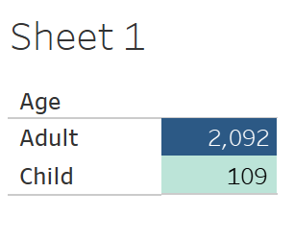

1. 2,092 adults, 109 children.

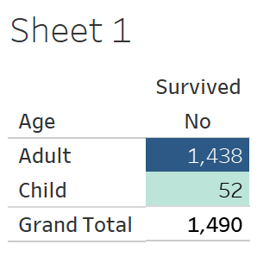

1. 1,490 died, 1,438 adults, 52 children.
2. Of those that died, 126 of them were female.

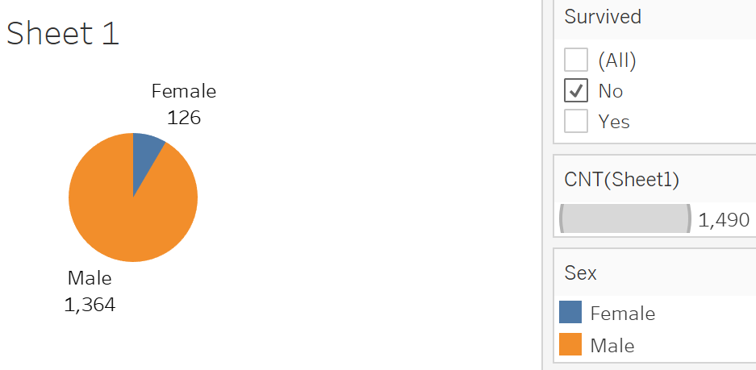

1. 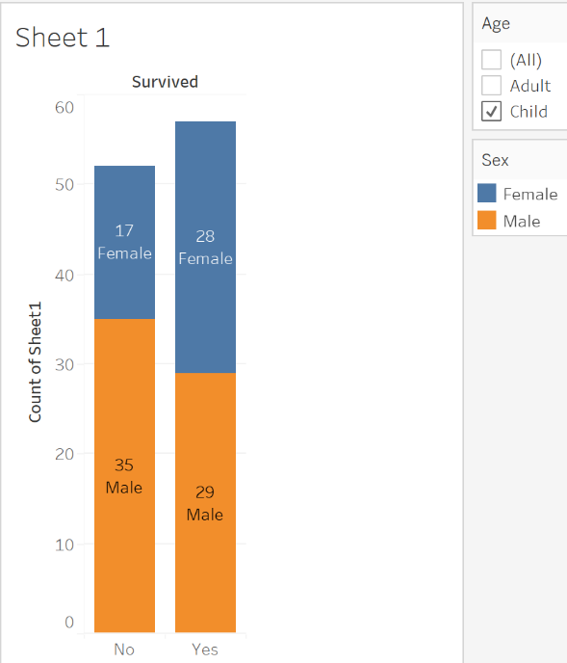Of those that survived, 29 were male children.
2. 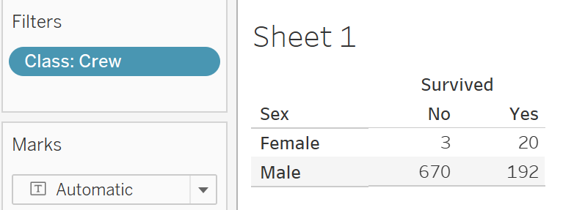Of those on the crew that survived, 20 were women.

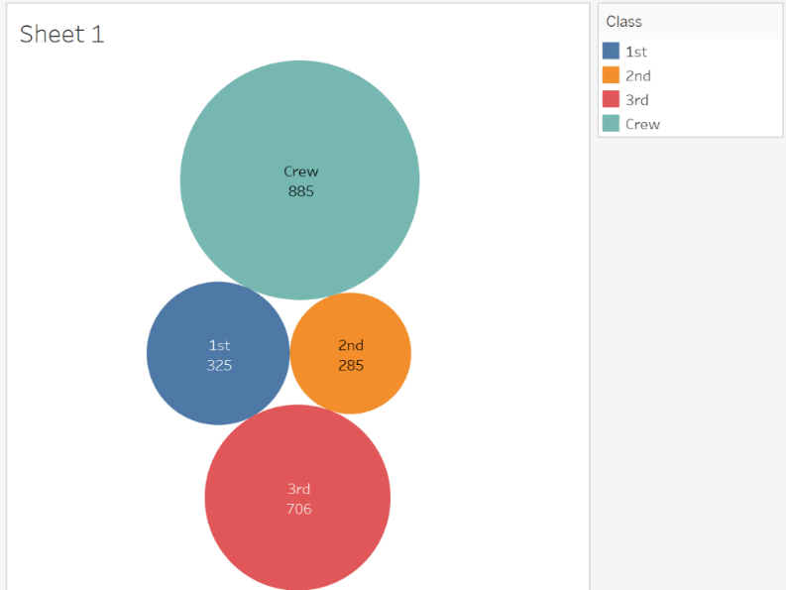

1. Of the classes on the ship, the Crew had the largest amount of people with 885. Of the non-crew, 3rd class had the most amount of people.
2. 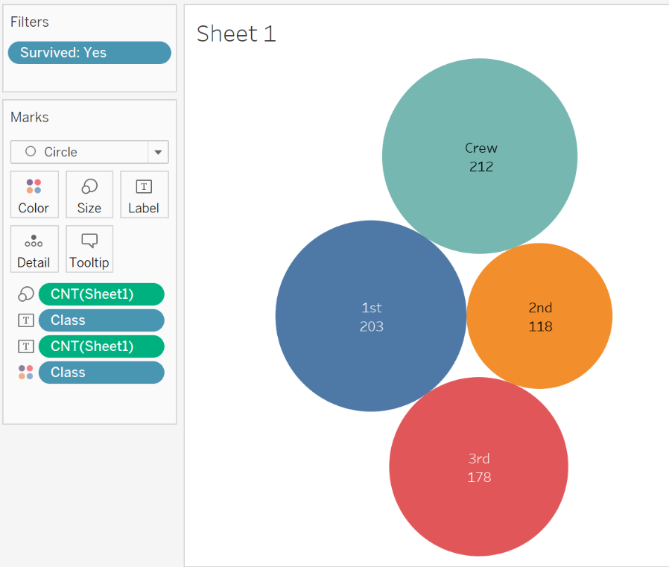Of the classes on the ship, the Crew had the most survivors with 212.

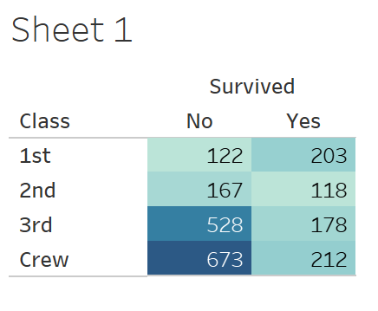

1. 528 3rd class passengers died.